Bitumen

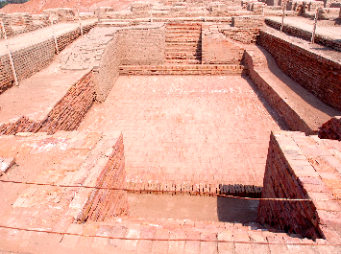
The Great Bath, Mohenjo-daro, Pakistan, located at the centre of the Citadel, is made of fine baked waterproof mud bricks and a thick layer of bitumen, presumably to keep water from seeping through the walls, which indicates that it was used for holding water. Image: CC BY-SA 3.0

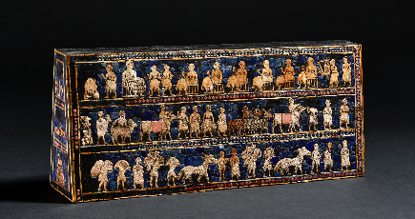
Peace side — ‘Standard of Ur’ (replica); Wood, shell, limestone, lapis lazuli, bitumen, inlaid; Findspot: Royal Cemetery at Ur, Iraq; 2500 BCE; The British Museum (replica of 121201)

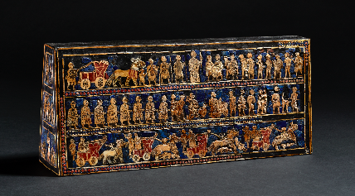

War side — ‘Standard of Ur’ (replica); Wood, shell, limestone, lapis lazuli, bitumen, inlaid; Findspot: Royal Cemetery at Ur, Iraq; 2500 BCE; The British Museum (replica of 121201)

